How the detection mechanism works:
First, I compute the average Mel-frequency cepstrum (MFCC) of the audiofiles. This is the numeric representation of a song as a vector. The code separates the song into smaller sections and computes the MFCC of that section, then we take the average of all these MFCCs and find a single vector with thirteen coefficients. With this, we can measure how similar two songs are by calculating the cosine distance between two songs, ranging from 1 (identical) to 0 (unrelated). We can set a limit between 0 and 1 to determine how similar songs are where, after a certain threshold, two audio files are related enough to be considered a copyright infringement.
Performance:
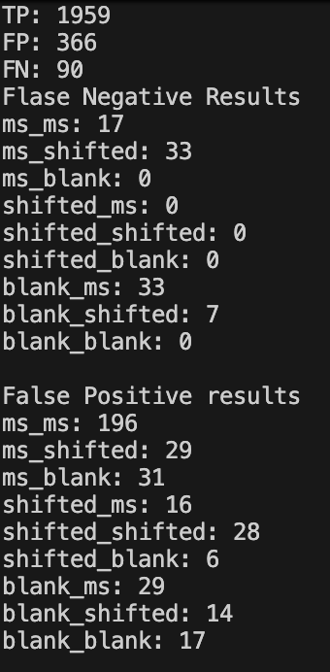
The following image shows the detection model’s performance, ms means the compared file is a snippet of the original file, shifted means the song had been pitch shifted, blank means the song underwent no modification. As we can see, the model got around 81% of the matches correctly, mostly failing by saying two different songs are actually a copyright violation. In this case, it was underperforming with audio snippet comparisons. It very rarely missed copyright violations, but most of these misses were also associated with snippets when compared to either the unmodified song or to its pitch shifted version.
The model seems to be working well, but the threshold might be a little too large, meaning we are flagging too many different songs as violating copyright. Also audio snippets seem to avoid detection a little easier than pitch shifting the songs.
Technical Challenges and Limitations:
First, I tried calculating the cosine differences of the fingerprints generated by the chromaprint library using the same cosine difference. The problem I arrived at is that the songs were too similar, meaning the similarity rates of all comparisons were too close to 1, raising my threshold to 0.99. The MFCC measurement still faced similar issues but provided slightly more consistent results.
I only took the average MFCC because the time taken to compare two songs was too large if every MFCC vector calculated for the full song was taken into account. Matrix multiplication optimizations would work great here, but for a lack of time and understanding I decided to simply take the average vector.
The songs used all come from the same album, which caused them all to be very similar. With some research about MFCCs, I found out that they are great for comparing timbre, instrumentation, and overall sound color, but underperform at distinguishing rhythm, melody, lyrics, or long-term song structure.

